RESUME
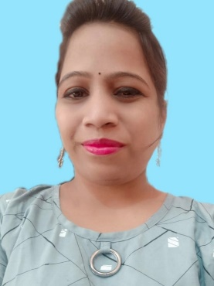

SUBHASHREE SETHI
AT - Nalipada,
PO. - Arjunpur,
P.S. - Khurda,
Dist. - Khurda(Odisha)
Pin- 752057
Mob. - 7978736510
E-mail : subhashreesethi814@gmail.com

OBJECTIVE:

To enhance my knowledge & capability by working in a dynamic organization that prides itself in giving substantial responsibility to new talent. Also seek a platform to put best of my efforts and knowledge in to practice for ensuring growth of the organization and my professional growth too.

EDUCATIONAL QUALIFICATION:

o B.Sc in PRANANATH COLLEGE (AUTO)
Khordha, Odisha, India
o Higher Secondary Education, C.H.S.E Board
SURAJMAL COLLEGE RAMPELLA, SAMBALPUR Odisha , India
o Secondary School Education, B.S.E,2008
PANCHAYAT HIGH SCHOOL RAMCHANDRA NAGAR, SAMBALPUR, Odisha ,India

COMPUTER SKILL & SKILL ENHANCEMENT TRAINING TAKEN

- P.G.D.C.A from Kalinga Vikash Computer Sambalpur
- Tally from 9.0 from JVCCE Khurda
- Soft-skill from Gateway Spectrum
- Web design & developing (HTML,CSS,JAVA SCRIPT,JQUERY, BOOTSTRAP ,PHP,PHOTOSHOP)

EXPERIENCE

- Worked with Gateway Spectrum as a Trainee from 1st July 2016 to 12th February 2017.
- Worked with Sonatech Infosolution Pvt. Ltd. as a Support Executive from 16th February 2017 to 30th June 2017.
- Worked as a customer care executive in Karvyi.
- Worked in Axis Bank as credit card telecaller and clint handling process.
- Now I’m working at SEPEANSE TECHNOLOGY PVT. LTD. as Web UI developer in PHP Since January 2022.
LiveProjects: www.majalitours.com / shiratoursandexcursions.com /kobotongoandsons.com / youthreproductivehealth.org / toursuganda.com / johnbulltoursuganda.com
My Strengths

- I am confident and carry good soft skill & have positive attitude.
- I value others time and punctual too.
- I can adjust to situations and work on diversity.
- I am a quick learner.
HOBBIES:

- Playing Chess.
- Reading Novell at my free time.
- Surfing Net for information and attached with social media too.

PERSONAL PROFILE:

Name : SUBHASHREE SETHI

Father’s Name : BALABHADRA SETHI

Date of Birth : 02th MARCH 1996
Nationality : Indian
Religion : Hinduism
Language Known : Odia, Hindi & English
Sex : female
Marital Status : Single
DECLARATION:

I do hereby declare that all the information provided above
is true to the best of my knowledge and belief.

Date :

Place : (Subhashree Sethi)

